SMNIEEE Machine Learning Workshop
How to use the materials at home

Brian Albertson (brian.albertson@ieee.org)
Updated: November 21, 2018

0) Introduction

This document will explain a few relatively easy ways to run Jupyter notebooks outside of the Southern Minnesota IEEE Section’s Machine Learning Workshops. Participants in SMNIEEE MLW series are the intended audience, but anyone who finds this document is welcome to use it for whatever help it offers them.

1) Get a Jupyter Notebook Server

This section will cover two ways to run Jupyter notebooks. The first is similar to the workshop experience, where a cloud server runs your code and communicates with you through the internet. The second installs Jupyter and Python on your computer. Your computer will run your code and will interface with you through your web browser.

1.1) Run Jupyter on a Free Server

Google offers a free server called Colaboratory where you can upload and run Jupyter notebooks. You’ll need an account with Google to use it.

https://colab.research.google.com/notebooks/welcome.ipynb

If you prefer not to use Google, there are other free servers by different providers listed below.

The first time you visit, a window should pop up that has a button to upload notebooks. For instructions on uploading notebooks, see section 2.

Notebooks that you create and upload are saved in your Google Drive.

Details on the interface and limitations of this server are not provided in this document.

See also:

- A guide to running IPython (aka Jupyter) notebooks on IBM Bluemix: https://www.ibm.com/developerworks/cloud/library/cl-ipython-app/cl-ipython-app-pdf.pdf

- Microsoft Azure Notebooks: https://notebooks.azure.com/

- Notebook viewer (to run the code, click “Execute on Binder” in the top right-hand corner when viewing a notebook): http://nbviewer.jupyter.org/

1.2) Run Jupyter on Your Personal Computer

If you’d like to have the control, privacy, and offline freedom of running the notebooks on your computer, follow these installation instructions.

There are many ways to install Python and Jupyter. This section will explain how to use the Anaconda Distribution, because it works the same for Windows, macOS, and Linux. It also includes many libraries used for Data Science and Machine Learning, including Pandas, NumPy, SciPy, and matplotlib.

Go to the Anaconda download page:
https://www.anaconda.com/download/

Choose your operating system and download the Python 3 option. You do not need to provide your email when it asks with a pop up. Wait for the executable to download, then run it. Follow the instructions of the installation wizard.

When installation has completed, run the following command in the Terminal (Mac/Linux) or Command Prompt (Windows):
This will print some information about the notebook server in your terminal, including the URL of the web application (by default, http://localhost:8888). It will then open your default web browser to this URL.

jupyter notebook

Note: You can run Jupyter without a browser:

jupyter notebook --no-broswer

2) Accessing the Notebooks

After you’ve completed the section above, you should be able to run a Jupyter environment either on the cloud or your computer. The next step is to run the workshop notebooks in that environment. This section will provide two options for loading the notebooks into Jupyter. Keep in mind that once you have a Jupyter environment, you’re free to write your own notebooks or search for others that interest you. Here’s a collection of notebooks covering a broad range of topics: https://github.com/jupyter/jupyter/wiki/A-gallery-of-interesting-Jupyter-Notebooks

The repositories used or referenced in the workshop follow:
- https://github.com/smnieee/ml_workshop
Machine Learning notebooks created by SMNIEEE.

- https://github.com/ehmatthes/intro_programming
A curriculum for learning how to program with Python. Find the notebooks in the ‘notebooks’ directory/folder.

- https://github.com/masinoa/machine_learning
A course on machine learning put together by professors from various universities

- https://github.com/jupyter/notebook
Notebooks created by Jupyter that explain how to use notebooks. Find the notebooks in the ‘docs/source/examples/Notebook’ directory/folder.

2.1) Upload Directly from GitHub

If you chose to install Jupyter on your computer in the section above, you’ll need to follow the instructions in section 2.2 to download the notebooks onto your computer.

If you chose to run Jupyter on Google’s cloud, you can run notebooks directly from GitHub. Go to File → Upload Notebook, then select the GITHUB tab. When you paste the URL of a GitHub repository, notebooks in the repository will be shown. Select the notebook(s) that you want.

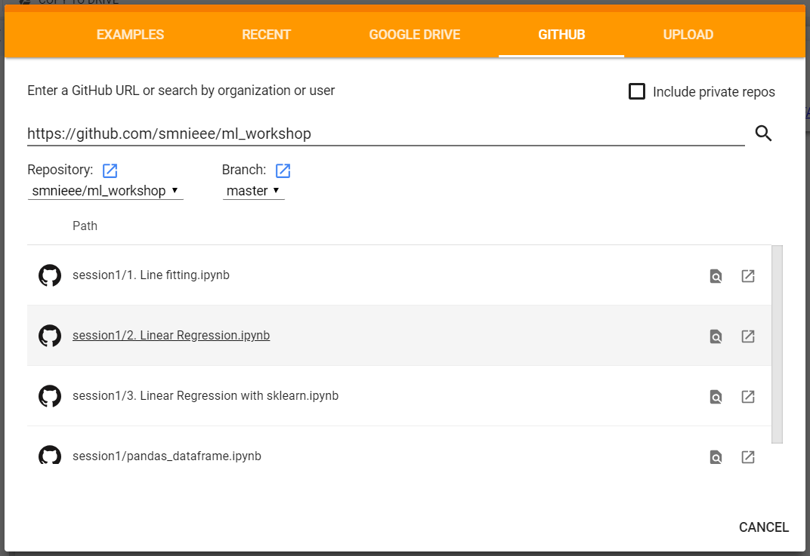

2.2) Download to Your Personal Computer

All of the notebooks provided during the workshop are publicly available on GitHub. Keep in mind that only the ‘ml_workshop’ repository is owned and managed by SMNIEEE. This subsection will explain how to download GitHub content onto your computer.

Start by visiting one of the repositories listed at the top of this section. On the repository’s home page, there should be a green “Clone or download” button. Under that button, there are a few options. The easiest thing for most people will be to “Download ZIP”. This will download a zip file through your web browser. Afterward, unzip/extract the file and move it to a convenient working directory/folder.

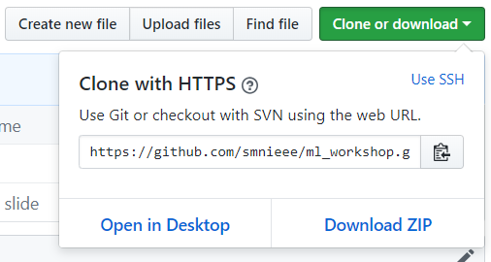
You can also use git to clone the repositories via HTTPS or SSH. This document will not cover how to install or use git. https://git-scm.com/

If you chose to use Google’s free server, you can go to File → Upload Notebook, then select the UPLOAD tab. Use the “Choose File” button and browse to the location where you downloaded the repositories.

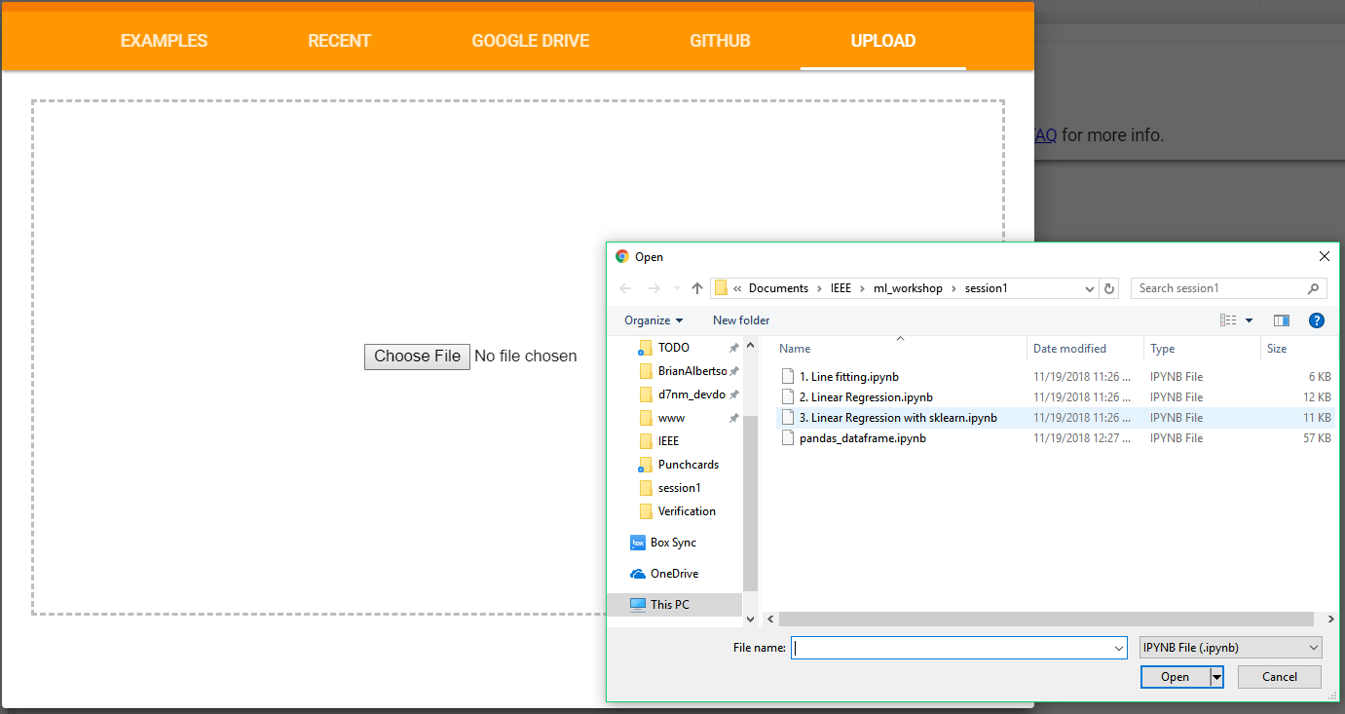

If you chose to run Jupyter on your computer, you can use the Jupyter Dashboard to browse to the directory/folder where you downloaded the repositories. You can also use the “Upload” button on the Dashboard to move the notebooks to your Jupyter home space.

To open a notebook directly from the Terminal/Command Prompt:

jupyter notebook [/your/path/to/notebook.ipynb]

To open open the Jupyter dashboard to a certain directory/folder:

jupyter notebook --notebook-dir=[your/path/to/]

3) Go Forth

That’s all you need! Code, experiment, learn, and please continue to participate in our workshops!

